Opening of department resource center

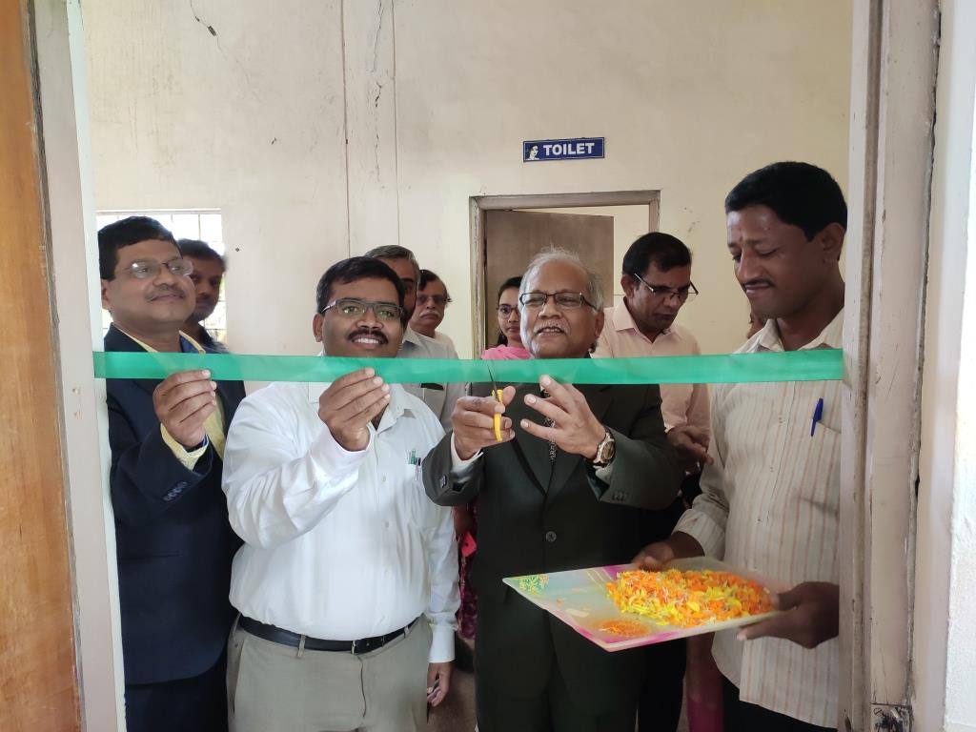
The department has started a resource center to make the availability of Technical books, Non-technical books, Newspapers, IIM news letters to its staff and students. The resource center was inaugurated by Sri. K.K.Ghosh, Chairman, IIM Vizag chapter on12th December 2019. The IIM Vziag chapter has donated books worth of Rs.10,000.00 to the resource center on 4th February 2020. Now the resource contains around 50 titles of technical books & non-technical books. It is providing two newspapers in local language and two newspapers in English to the students.

