A one day National conference on "Innovations in Material Science & Technology"

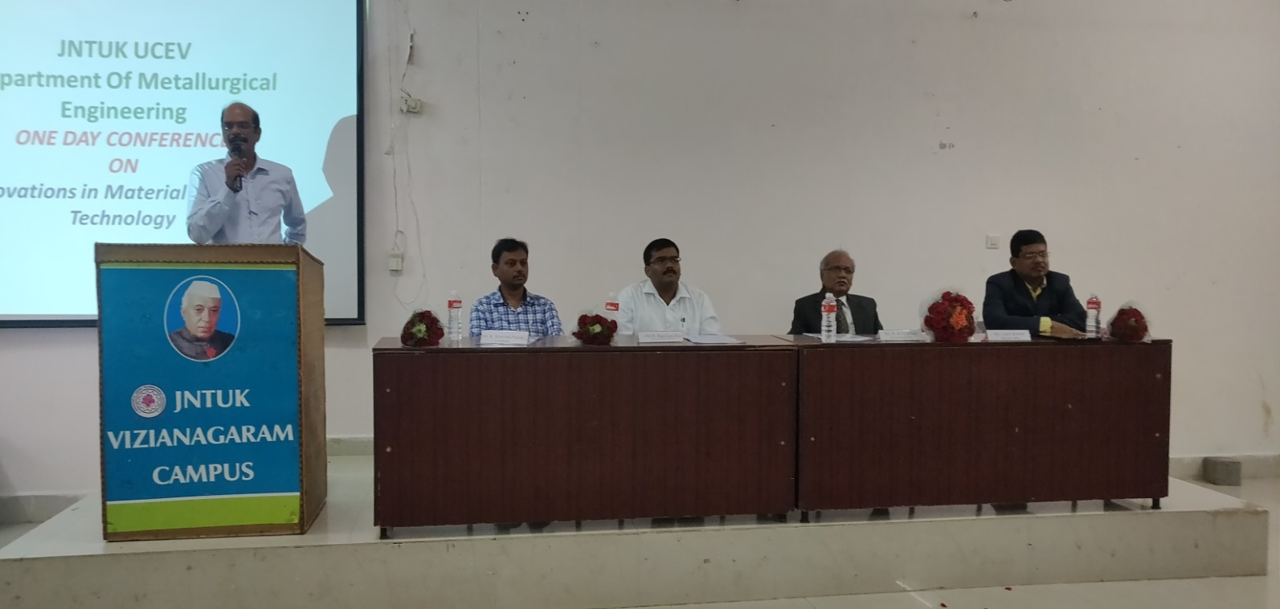
The Department of Metallurgical Engineering has organized a one day National conference on "Innovations in Material Science & Technology" on 12th December 2019 in association with the Indian Institute of Metals, Vizag chapter.

