A National workshop on
“Fatigue, Fracture and Creep of Materials”
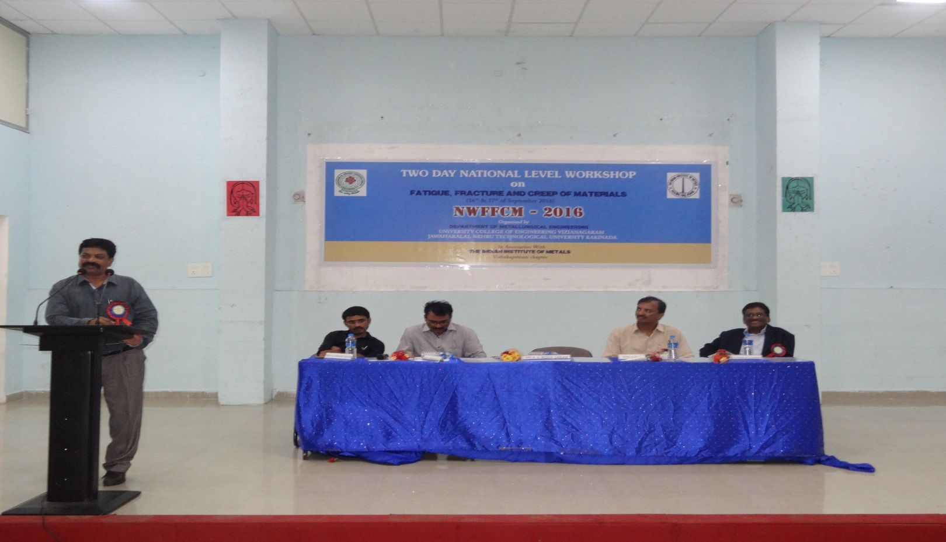
A National workshop on “Fatigue, Fracture and Creep of Materials” in association with Indian Institute of Metals, Vizag chapter on 16th & 17th September 2016

