“International Conference on Advanced Materials and Manufacturing Processes (ICAMMP-2018)”

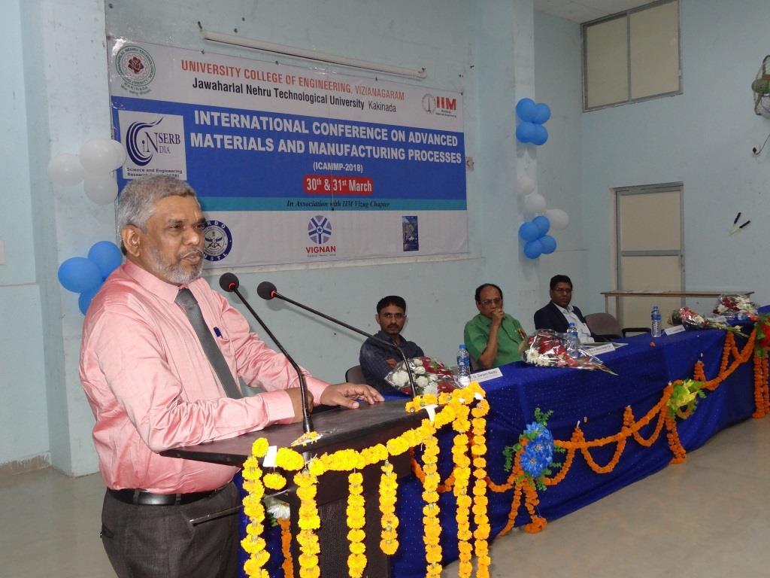
This is the first international conference organised by the department of Metallurgical Engineering since its inception.
The conference is titled as “International Conference on Advanced Materials and Manufacturing Processes (ICAMMP-2018)” and it was conducted in association with Indian Institute of Metals, Vizag chapter

