Hands-on experience program details

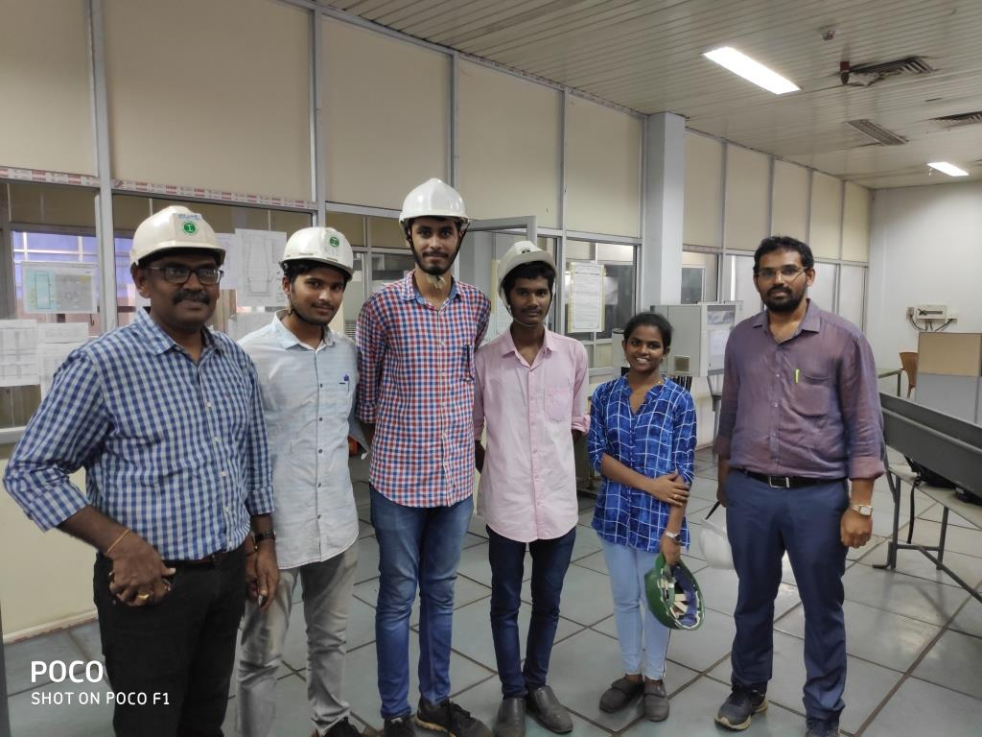
Total four students (Mr. R.Sai Jaswanth Kumar, Kum. Ch.Axitha, Mr. S.Sri Harsha and Mr. Satyabrath Chowdary) selected for Hands –on experience program at Vizag steel plant, an initiation taken by Vizag Steel Plant to provide a better practical knowledge for academically meritorious students studying B.Tech in Metallurgical Engineering at JNTUK-UCEV.

