EISEN2K20
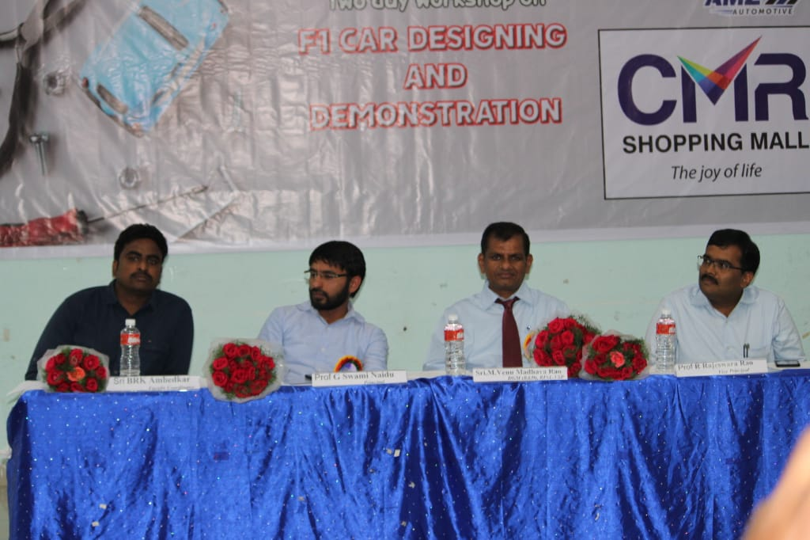
A two day national level technical symposium “EISEN2K20” in association with Indian Institute of Metals, Vizag chapter was organized on 18th & 19th February 2020. Expert talks were delivered on Advances in iron and steel making and recent trends in NDT. Many of students, faculty from various institutes and people from industry participated in this technical symposium.

