A two day national level technical symposium “EISEN2K19”

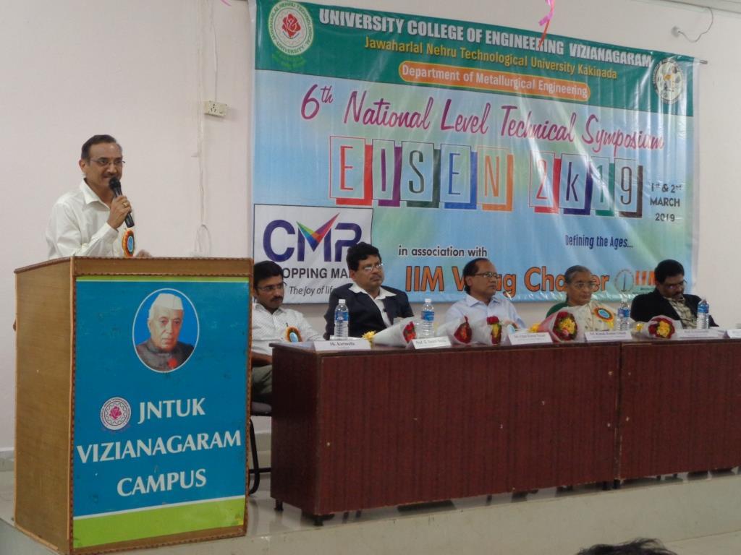

A two day national level technical symposium “EISEN2K19” in association with Indian Institute of Metals, Vizag chapter was organized on 1st & 2nd March, 2019. A one day workshop was organized in connection with the “EISEN2K19” expert talks were delivered by Prof. B.S.Murthy IITM and Dr.K.Gopala Krishna Priniciple scientist from NML Jamshedpur

