A two day national level technical symposium EISEN2K18

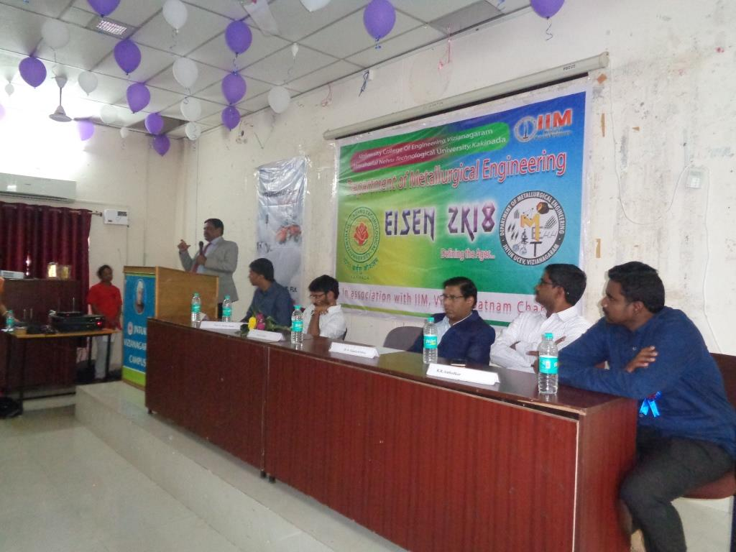
A two day national level technical symposiumEISEN2K18 was organized by Department of Metallurgical Engineering in association with Indian Institute of Metals, Vizag chapter on 20th & 21st February 2018. A workshop was conducted in connection with this technical symposium on 21st February 2018. Eminent persons from Educational institutes and R&D centers were delivered expert talks in this workshop. The expert talks for this workshop include
"Metallurgical Processes for fabrication of Nano materials for Neon Materials", " Rain Water harvesting & Environmental issues in Metallurgical Industries" and "Advanced Materials" .

