A two day national level technical symposium EISEN2K17

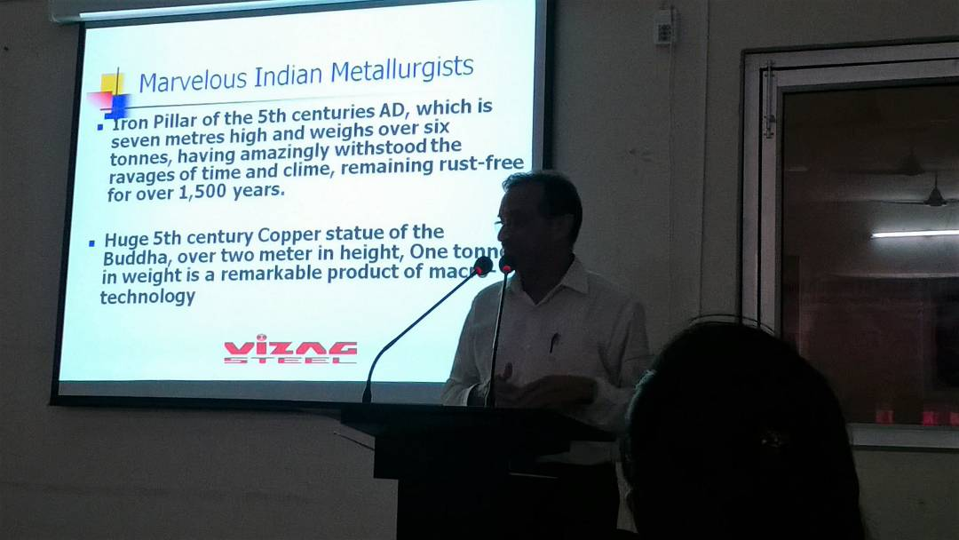
A two day national level technical symposium EISEN2K17 was organized by Department of Metallurgical Engineering in association with Indian Institute of Metals, Vizag chapter on 09th & 10th March 2017

