A two day national level technical symposium EISEN2K16

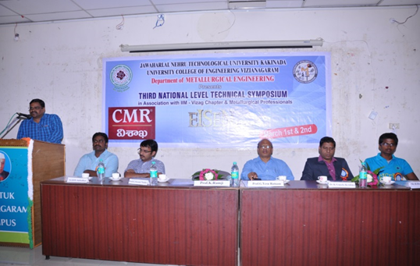
A two day national level technical symposium EISEN2K16 was organized by Department of Metallurgical Engineering in association with Indian Institute of Metals, Vizag chapter on 01st & 02nd 2016

