A one day national workshop on “Advances in Composites and Ferro Alloy Technology” (ACFAT17
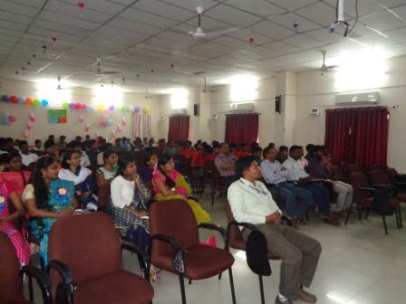
A one day national workshop on “Advances in Composites and Ferro Alloy Technology” (ACFAT17) was organized by Department of Metallurgical Engineering In association with IIM Vizag Chapter on 22nd August 2017

